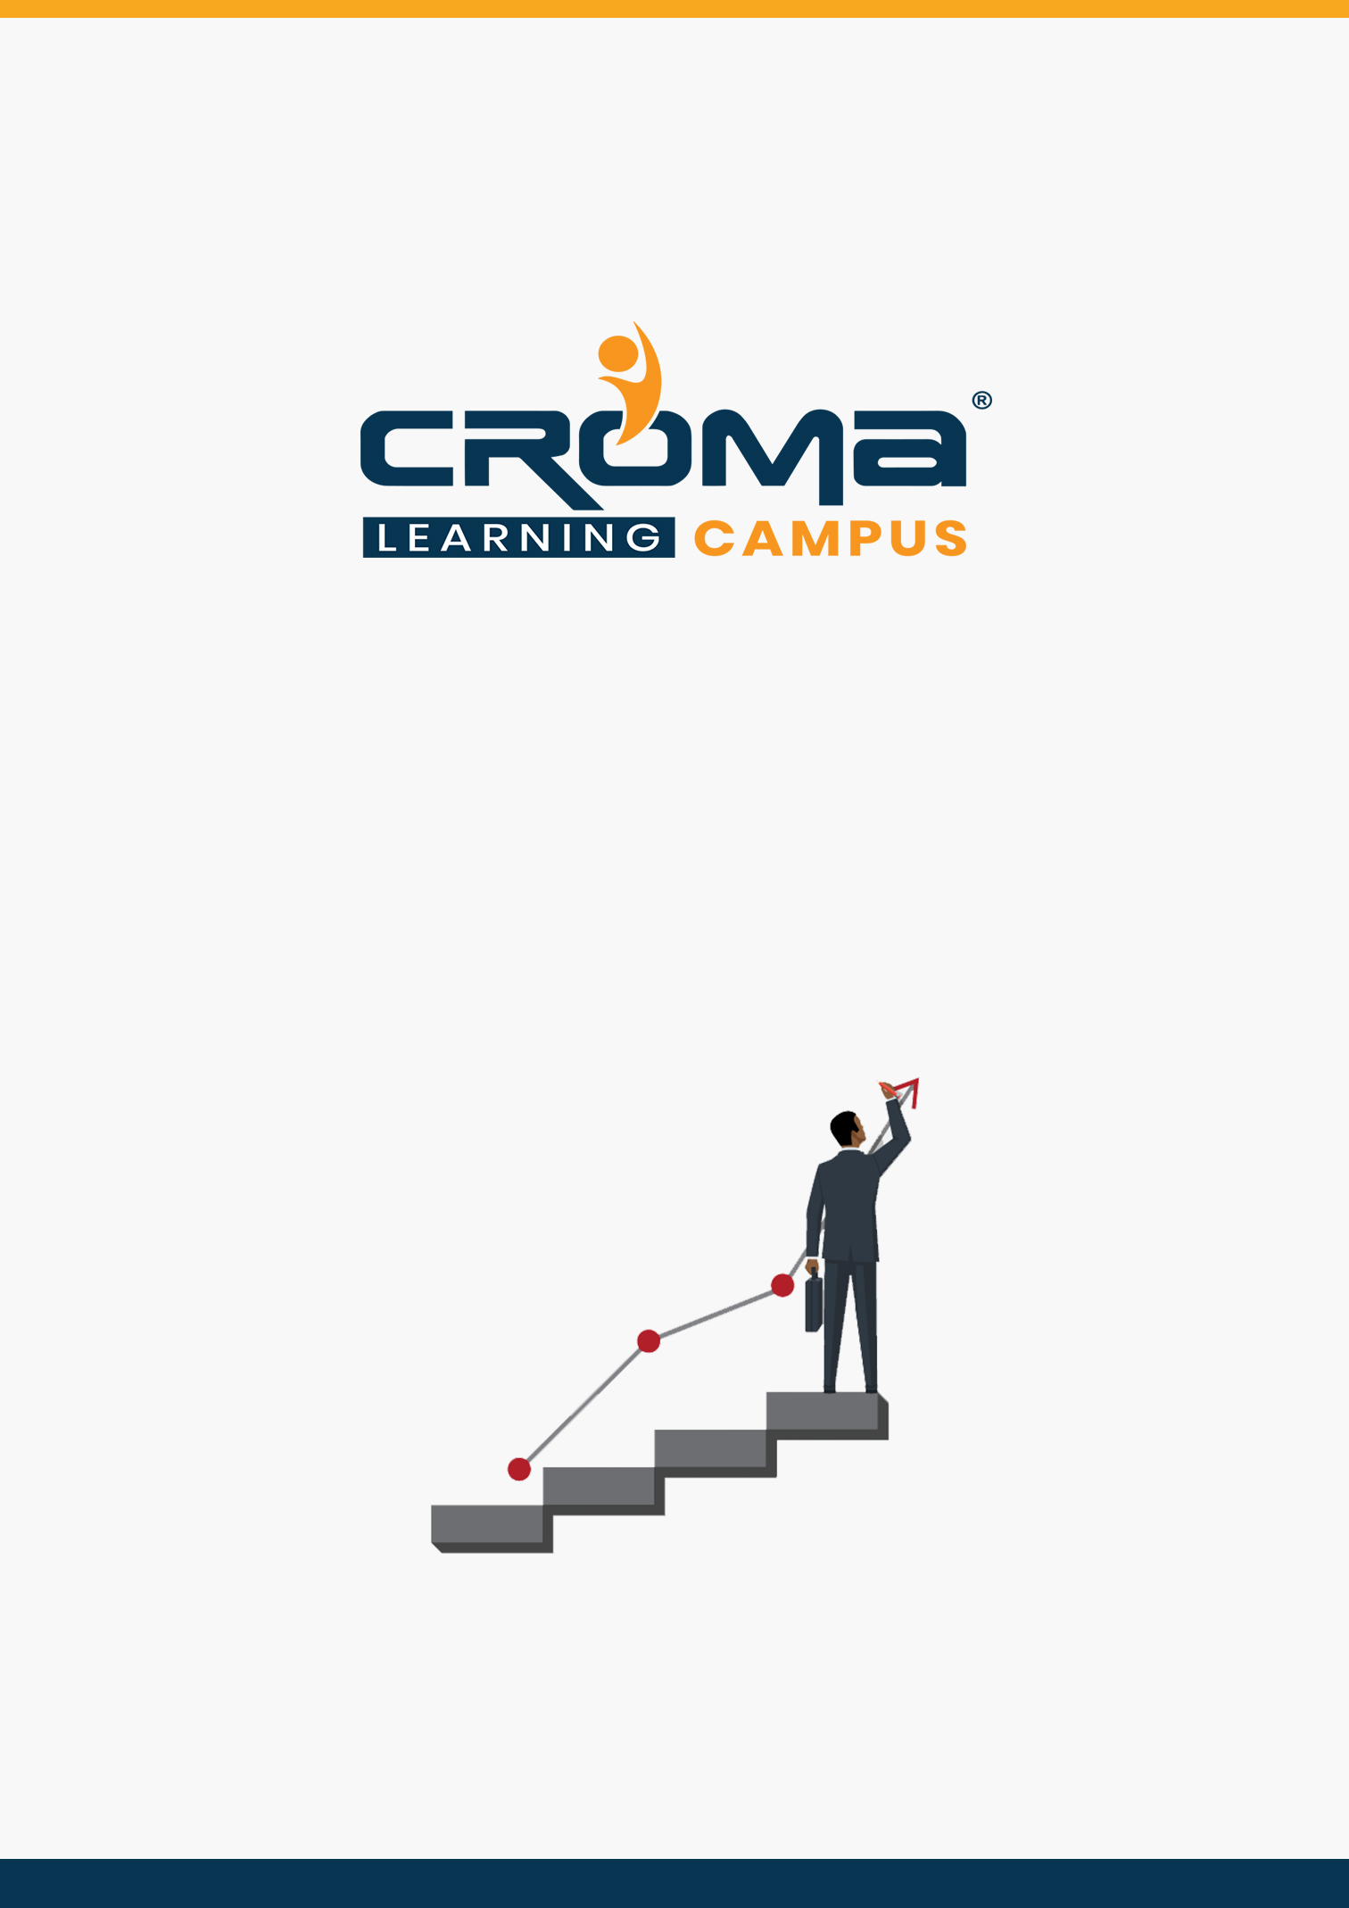

**SAP Controlling Training Curriculum**

**STRUCTURE**

**www.cromacampus.com | helpdesk@cromacampus.com | +91-120-4155255**

**SAP Controlling Training Curriculum**

*“Delivering Knowledge to help you make your mark in the world”*

**Course Objectives:**

|  |  |
| --- | --- |
| * Master SAP CO Module basics in-depth * Prepare for SAP FICO Certification Exam * Become an SAP FICO Consultant * Learn Cost Element Accounting in-depth * Learn Cost Center Accounting in-depth * Learn Profit Center Accounting in-depth | * Multi-level Product Cost Controlling * Learn about Product Cost Planning * Learn all about internal Orders * Learn All about Profitability Analysis * Work in Process and Variance Calculation * Settlements in SAP CO |

**Course Description:**

Our SAP CO (Controlling) training at Croma Campus aims at providing comprehensive knowledge of SAP controlling concepts in-depth with multiple examples and real-world scenarios. Our training program is designed in such a way that it will help you to master all functionalities and configurations available within the module. Also, it will help you to gain sufficient knowledge to appear for the SAP FICO exam and become an SAP CO consultant by applying to multiple job openings in the same domain.

**SAP CO: A Quick Introduction**

SAP has multiple modules and SAP CO is one of the proven finance modules that help to coordinate, monitor, and optimize all processes within an organization. The main objective of this module is to help information managers and decision-makers where the organization’s money is being spent. It does not obey any legal restriction but considered a vital internal cost accounting tool.

The module involves both recordings of production factors and services rendered by an organization. Further, it helps to manage and configure the master data that covers cost elements, cost centers, internal orders, profit centers, profitability analysis, and more. In brief, we can say that the SAP CO module focuses more on planning and monitoring tools.

**SAP CO Modules**

SAP controlling Module is divided into six major components that are designed with specific purposes. We will cover each of these components in our training program one by one to deliver maximum knowledge about the module. These components are:

* **Cost Element Accounting**: This component gives the idea of the Company’s cost and revenues based on profit and loss statements that are also termed as income statements.
* **Cost Center Accounting**: This component will provide an overview of costs associated with internal departments or divisions like HR, Sales, Marketing, or production departments.
* **Internal Orders**: This component will help to manage costs for smaller internal projects or non-fixed assets.
* **Product Cost Controlling**: This component will help to manage the data needed to produce Company goods and services. It will also include Overhead Cost Calculation and Activity-based Calculation.
* **Profitability Analysis**: It helps you to analyze the profit statements that further help managers in making sound decisions.
* **Profit Center Accounting**: This component handles all of the cost data related to the company's business lines. It deals with both expenses and revenues, unlike Cost Centers, which deals only with expenses.

**Course Curriculum Content:**

**Chapter 1: SAP CO Basics**

* Introduction to SAP CO Module
* Major Components of SAP CO
  + Cost Element Accounting
  + Cost Center Accounting
  + Internal Orders
  + Product Cost Controlling
  + Profitability Analysis
  + Profit Center Accounting.
* Basic SAP CO Settings
* Controlling Area in SAP CO
* Steps to maintain the Controlling Area
* Company Code Assignment to Controlling Area
* Number Range for Controlling Area
* Versions Management in SAP CO

**Chapter 2: Cost Element Accounting: SAP CO – CEA**

* What is Cost Element Accounting?
* SAP Cost Element Accounting Configuration
* What are Cost Elements?
  + Primary Cost Elements
  + Secondary Cost Elements
  + Cost Element Categories
  + Cost Element Group
* Create a new cost element in SAP CO
* Create Primary Cost Elements
* Create Secondary Cost Elements
* Create Cost Element Categories
* Create Cost Element Groups
* SAP Cost Element Accounting TCodes

**Chapter 3: Cost Center Accounting: SAP CO - CCA**

* What is Cost Center Accounting (CCA)?
* CCA Components
  + Cost center configuration
  + Activity type configuration
  + Statistical key figure configuration
* Configuration Steps for CCA
* Activate CCA in Controlling Area
* What are Cost Centers in SAP?
* Why do you need Cost Centers in SAP?
* Steps to Create Cost Centers
* Cost Center Categories in SAP
* Steps to Create Cost Center Categories
* Cost Center Hierarchy in SAP
* Steps to define Cost Center Hierarchy in SAP
* Cost Center groups in SAP
* Steps to Create Cost Center groups
* Posting to Cost Centers
* Re-posting of CO line items
* Planning of Cost Centers
* Overhead Calculation
* Period End closing activities in cost center accounting – Assessment, Distribution, Periodic Re-posting, Activity Allocation
* SAP Cost Element Accounting TCodes

**Chapter 4: Internal Orders**

* What are Internal Orders?
* Why do you need Internal Orders?
* Internal Orders vs Cost Centers vs Cost Elements
* Steps to Create Internal Orders
* Types of Internal Orders
* Real Orders
* Statistical Orders
* Uses of Internal Order Types
* Settlement of Internal Orders
* Internal Order profiles
* Settlement Profile
* Planning Profile
* Budget Profile
* Internal Order Planning
* Enter Budget Information
* Actual Data posting
* Display Internal Order Details
* Display budget control availability
* Tolerance for Budgeting and availability control
* Internal Order to AUC settlement
* AUC to Asset Settlement
* Internal Order with Investment management
* Information Reports
* Settlement of Real Internal Orders to Cost Centers
* SAP Internal Orders TCodes

**Chapter 5: Product Cost Controlling**

* What is Product Cost Controlling?
* Data Flow in Product Cost Controlling
* Cost Objects in Product Cost Controlling
* Cost Sheets in Product Cost Controlling
* Product Cost Planning with Quantity Structure
  + Create Bill of Material
  + Define Overhead Keys
  + Create Activity Type Master Records
  + Planning for activity hours
  + Activity type price calculation
  + Create work center master records
  + Create Routing
  + Define Cost Sheet
  + Assignment of Cost sheet to costing variant
  + Creation of cost estimate with quantity structure
  + Marking
  + Releasing
  + Creation of Cost Estimate without quantity structure
  + Collective Cost Estimate
* Unit Cost Estimate
* Material Cost Estimate without Quantity Structure
* Product Cost Calculation with Quality structure
* Work in Process Calculation
  + Define Result Analysis Keys
  + Define Cost Elements for WIP Calculation
  + Define Result Analysis Versions
  + Define Valuation Methods (Actual Cost)
  + Define Line IDS
  + Define Assignments
  + Define Update
  + Define Posting Rules for Setting work in Process
* Standard Product Cost calculation
* Product Cost Calculation by Order
  + Define Costing Variant
  + Check Costing Variant to Manufacturing Orders
  + Define Goods Received Valuation for Order Delivery
* Actual Product Cost Calculation with Material Ledger
  + Activate Valuation Areas for Material Ledger
  + Assign Currency Types to Material Ledger Type
  + Assign Material Ledger Types to Valuation Area
  + Maintain Number Ranges for Material Ledger Documents
  + Activate Actual Costing
  + Assignment of Accounts for Automatic Posting
* Settlement of Variance to Accounts
  + Create Settlement Profile
  + Create PA Transfer Structure
  + Maintain Number Ranges for Settlement Documents
  + Define Variance Keys
  + Define Default variance Keys for Plants
  + Define Target Cost Version
  + Assign Variance Key in Material Master
* Overhead Product Costing in SAP CO
* Activity-based Product Costing In SAP
* SAP Product Cost Controlling TCodes
* SAP Overhead Costing TCodes
* SAP Activity-based Costing (ABC) TCodes

**Chapter 6: Profitability Analysis (SAP CO-PA)**

* Introduction to Profitability Analysis (PA)
* Types of PA
  + Account-based COPA
  + Costing-based COPA
* Data Flow in Profitability Analysis
* Maintaining the operating concern
* Assignment of Controlling area to operating concern
* Activating the profitability analysis
* Define number ranges for actual postings
* Mapping of SD conditions types to COPA value fields
* Maintain characteristics
* Maintain Value Fields
* Define Profitability segment characteristics
* Maintain Characteristics
* Define Characteristics Derivation
* Define and Assign Valuation strategy
* Define Keys for accessing material cost estimates
* Assign costing keys to any characteristics
* Assign Value Fields
* Define Number Ranges for Planning Data
* Maintain Versions
* Assign Quantity Fields
* Define PA Transfer Structure
* Direct Posting from FI/MM
* Value Flow from Cost Center to COPA
* Value Flow from Internal Order to COPA
* Value Flow from Production Order to COPA
* COPA Summarization
* SAP Profitability Analysis TCodes

**Chapter 7: Profit Center Accounting**

* What is Profit Center Accounting?
* Basic settings for Profit Center Accounting
* Creation of Profit Centers
* Creation of Profit Center Groups
* Posting to Profit Center Via Financial Document (FI Interface)
* Control Parameters Maintenance for Actual Posting
* Versions management for Profit Centers
* Define Number Range for Profit Center Documents
* Create & Display Profit Center Master Records
* Assignment of Revenue elements for Profit Centers
* Assignment of Cost Centers To Profit Center
* Assignment of Materials to Profit Center
* Profit Center Planning
* Account Group creation in profit center accounting for planning
* Profit & Loss Account Items Planning
* Balance Sheet Items Planning
* Generation of variance reports for Profit & Loss Account Items
* Generation of variance reports for Balance Sheet Items
* Create derivation rules for Revenue Elements
* Create derivation rules for Balance Sheet Accounts
* Standard Hierarchy in Profit Center Accounting
* Creation of Profit Center using Standard Hierarchy in SAP
* Document Splitting
* SAP Profit Center TCodes

**Chapter 8: Placement Guide**

* What is an Interview?
* Tips to clear an Interview
* Common Interview questions and answers
* SAP Controlling Interview Questions and Answers
* Resume Building Guide
* Attempt for ***SAP Global Certification Exam***
* Start applying for Jobs

**SAP Global Certification Exam**

Today, when leading Companies need professionals with proven skills, SAP Global certification exam is a platform that is taken as the valid proof of your skills and practical knowledge. It helps you to differentiate your profile from the crowd. You can execute tasks with more confidence and speed. Also, get better salary packages when compared to other employees working in the same domain with the same years of experience.

**Types of SAP Global Certification**

* **Associate Level Certification** generally checks your fundamentals skills and knowledge.
* **Specialist Certification** focuses on particular role and you can choose anyone certification from the list of 150+ global SAP certifications based on your interests.
* **Professional Certification** focuses more on practical knowledge, project work, or detailed SAP solutions.

At the basic level, you can attempt for the “***CER006 - SAP Global Certification***” that will test your skills in SAP ecosystem. The exam is given online under a close monitoring through webcam. You can set your own timings and reschedule your exam if there is anything wrong. For each exam, you can give up to 3 attempts or even more based on the certification guidelines.

There is a total of 80 questions that you have to attempt within a timeline of 180 minutes. The price for this exam is $557 or 40K in Indian Rupees. On the successful completion, you will get badges for your accomplishments and become more recognized among other with a valid SAP certification that is considered worldwide by leading technology giants.

We wish you luck for a never-ending career journey with Croma Campus and take your first step towards success right away with the help of our expert team counselling and support.